**Resource Adequacy Status Report for July 2013**

**I. Data Updates**

|  |  |  |
| --- | --- | --- |
| Data | Status | Notes |
| 2019 Loads | Draft done  Final TBA | Preliminary 2019 loads under internal review  Ready for committee review by August  Final loads by early September |
| Generating resources | In progress | Preliminary by July |
| SW Market resources | In progress | New CEC data is available  Will also use AURORAxmp runs |
| Wind | In progress | Asked members to provide non-BPA fleet data |
| Energy Efficiency | In progress | Council staff, working on hourly shapes  Consider adding EE explicitly (instead of in loads) |
| Contracts | In progress | Will use BPA White Book data, need to format |
| New Peak vs. Energy Curves | By August | Update to 80-hydro years (McCoy contract) |
| Review INC/DEC | By August | BPA will provide any changes |
| Investigate BC market | TBA | New task needs assignment |
| Investigate non-NW wind and Entitlement as market supplies | TBA | New task needs assignment |
| Review transmission nomogram and capacities | TBA | Council staff |
| Identify policy assumptions for steering committee | TBA | John will send a draft list out to tech members  See Appendix C |
| Identify key sensitivities for detailed study | TBA | See section IV below |
| Data for 3rd node | TBA | Has not yet been assigned |
|  |  |  |
|  |  |  |

**II. Model Enhancements**

|  |  |  |
| --- | --- | --- |
| Enhancement | Status | Notes |
| Canadian operation | Done | Undergoing testing, will allow random hydro |
| 14-Period years | Done | Tested and approved |
| Weekly hydro | In progress | Will not be used for next assessment |
| Transmission nodes | In progress | Add Idaho node, needs data, testing |
| User interface | In progress | ETA late 2013 |
| Hourly hydro review | TBA | Multiple issues, eliminate “false” curtailments |
| Utility-version of Genesys | TBA | Contractor, BPA, Council staff |
| Develop means to model distributed generation | TBA | New task needs assignment |
| Develop means to model DR not already in load record | TBA | New task needs assignment |
| Develop post-processor DR evaluation model | Done | Needs better curtailment record |
|  |  |  |
|  |  |  |
|  |  |  |

**III. Proposed Meeting Schedule for 2013-14**

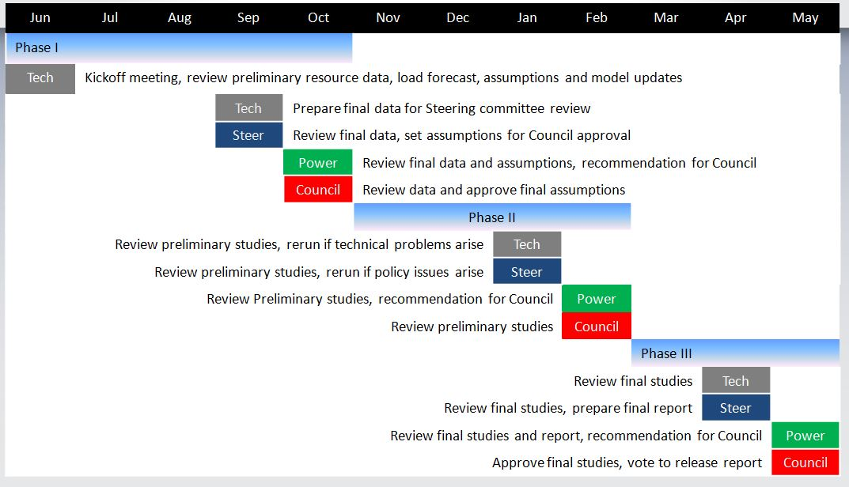

**IV. Policy Assumptions for Consideration by the Steering Committee**

1. Amount of SW market to include in the reference case
2. Amount of market provided by non-NW wind
3. Amount of market supply provided by BC
4. Amount of market supply available from the Entitlement
5. Amount of energy efficiency to include in the reference case (Council target or other)
6. Amount of new wind to include in the reference case (licensed-and-sited or RPS)
7. Shape for energy efficiency in the reference case
8. Assumptions relating to DR or distributed generation (more specificity needed)
9. Include sited-and-licensed resources in reference case or use different assumption?
10. Amount of borrowed hydro to include in reference case
11. Definition of standby resources (post processor adjustment of curtailment record to include the effects of standby resources not modeled in Genesys)

________________________________________

q:\jf\ra forum\2013\adequacy status july 2013.docx