State of the System Report for the Pacific Northwest’s Power Supply
Draft – Version 1: For Illustration Only


10/4/2011

State of the System Report for the Pacific Northwest
Pacific Northwest Resource Adequacy Forum
For Illustration Only – Version 1
Contents
Executive Summary 3
Adequacy Assessment 4
Use of Non-Firm Resources 6
Use of Demand Response and Standby Resources 10
Curtailment Statistics 12

Executive Summary
Caveat: This state-of-the-system report is meant for illustration only and is provided for the sole purpose of developing the form of the report. While the data used to assess the adequacy of the power supply for this report is current, there remain many unsettled issues regarding assumptions for non-firm and standby resources. Also, work continues on improving the hourly hydro dispatch logic. Thus, conclusions drawn from this report should be characterized as illustrative only and are not for distribution to the general public.
The current estimate of the loss of load probability (LOLP) for the 2015 operating year is 6.7 percent – above the 5 percent threshold that defines an adequate supply for the Pacific Northwest. Single hour shortfalls drive the LOLP to its current value. Assessing the LOLP solely based on energy considerations would yield a value of 1.4 percent. Furthermore, the bulk of the shortfalls occur in August. Adding as little as 400 MW of peaking capability during summer would bring the LOLP below the 5 percent threshold.
The region depends heavily on Northwest independent power producer (IPP) resources, with some level of contribution in every winter and summer month. The average winter energy contribution ranges from 750 to 1,500 megawatts-months per month and from 250 to 600 megawatts-months per month for summer.
The SW market is called upon as much as 11 percent of the time in winter and, if available, about 27 percent of the time in summer. The winter supply is available on peak and the proposed summer market would be available only during off peak hours. The Forum has yet to debate whether summer off peak purchases should be assumed for the adequacy assessment. They were modeled for this exercise to illustrate their potential use and benefit. Average contributions from the market are very small but, in the worst cases, average about 1,000 megawatt-months for January and about 400 megawatt-months for August.
Borrowed hydro (energy below the drafting rights elevation) is also used quite often, about 14 percent of the time in December but nearly 90 percent of the time in August. However, borrowed hydro energy is quickly replaced and the net end of month effect is minimal. In the worst cases, as much as 700 megawatt-months are used in one August and as much as 400 megawatt-months in one December. The assumed limit for borrowed hydro in any month is 1,000 megawatt-months. This level of use should not affect reservoir refill or maintaining minimum river flows for fish.
Demand response (DR) and standby resources SR) are called upon 8.6 percent of the time. By utilizing these resources, the LOLP drops from 8.6 percent to the current value of 6.7 percent.
A shortfall event is defined as a contiguous set of hours when resources fail to meet load. The expected number of shortfall events per year (not counting DR or SR) is 0.23. The average duration for an event is 14 hours and the average magnitude is about 15,000 megawatt-hours. The average peak curtailment is about 1,000 megawatts. Overall, the expected number of hours of curtailment per year (not events) is 3.3.

Adequacy Assessment
The current resource adequacy standard for the Pacific Northwest’s power supply is based on the loss of load probability (LOLP) metric. The LOLP represents the percentage of simulated yearly operations in which shortfalls exceed the peaking and energy capabilities of demand response (DR) actions and standby resources (SR) because these resources are not explicitly modeled. An LOLP greater than 5 percent indicates an inadequate supply.
In addition to the LOLP, other commonly used adequacy metrics are assessed. These alternative metrics are not a part of the standard but provide additional information regarding the frequency, duration and size of potential problems. The current assessment results are provided in Table 1.
Adequacy Metrics
Based on an Annual Assessment
Metric | Value | Units
LOLP | 6.7 | Percent
Use of DR and SR | 8.6 | Percent
CVaR (energy) | 67618 | MW-hours
CVaR (peak) | 2277 | MW
EUE | 3399 | MW-hours
LOLE | 3.3 | Hours/yr
Table 1
The 6.7% LOLP value indicates that the power supply is not adequate, in other words, the likelihood of a serious shortfall is greater than the region’s tolerance for such events. This high value is driven by single hour shortfalls in August. Assessing the LOLP based solely on energy results in a value of 1.4 percent. Figures 2 and 3 show the curtailment probability curves for total annual energy and single hour shortfalls.
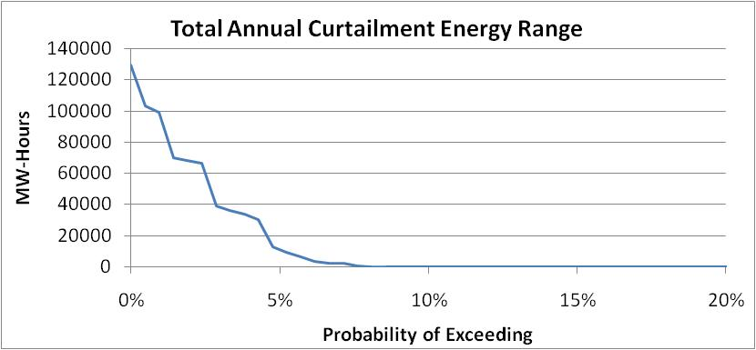
Figure 1
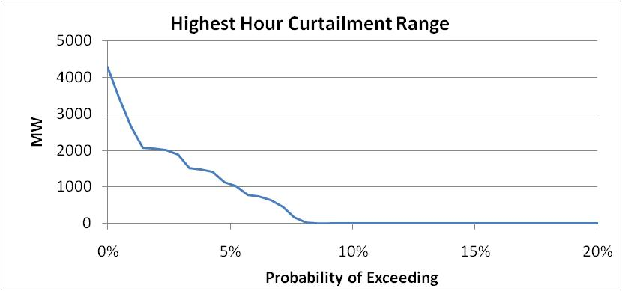
Figure 2

Use of Non-Firm Resources
The current adequacy methodology assumes that all reasonably available resources will be dispatched to avoid shortfalls. In this sense, the analysis represents the likelihood that demand will be served, cost notwithstanding. It is not intended to be a resource needs assessment, when costs and other factors are considered. But for this analysis, non-firm resources are included. These resources include regional Independent Power Producer (IPP) generation, out-of-region markets (primarily from the Southwest) and the use of borrowed hydro, which is energy derived by using water below the drafting rights elevation.
The general dispatch order for these resources is to first buy from IPPs, secondly to buy from out-of-region markets and lastly to use borrowed hydro energy. When borrowed hydro is used, it is replaced as quickly as possible, even if it means buying from out-of-region markets at a later time.
Figure 3 below illustrates the expected likelihood of use for each of these three types of non-firm resources by month. It should be noted that the SW market on-peak purchases are limited to the winter months only. Also modeled, but still under debate, is the availability of light load hour purchases made in advance of potential peak hour problems. This purchase-ahead resource is limited to 1000 megawatts in any light load hour and is called upon only when borrowed hydro is expected to be used during the next peak demand period.
Figure 4 shows the average contribution from each resource by month. However, average values are not always very informative. Thus, Figures 5-8 provide the dispatch probability curves for these 4 non-firm resources.
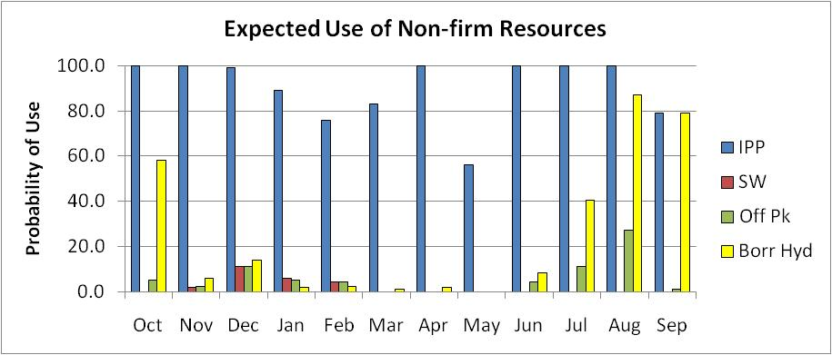
Figure 3
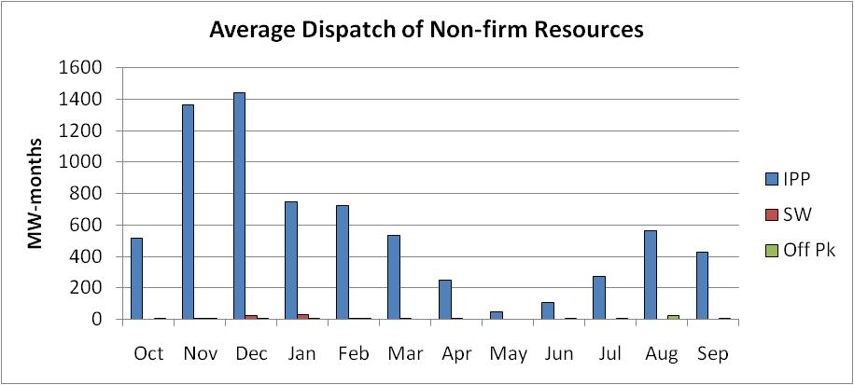
Figure 4
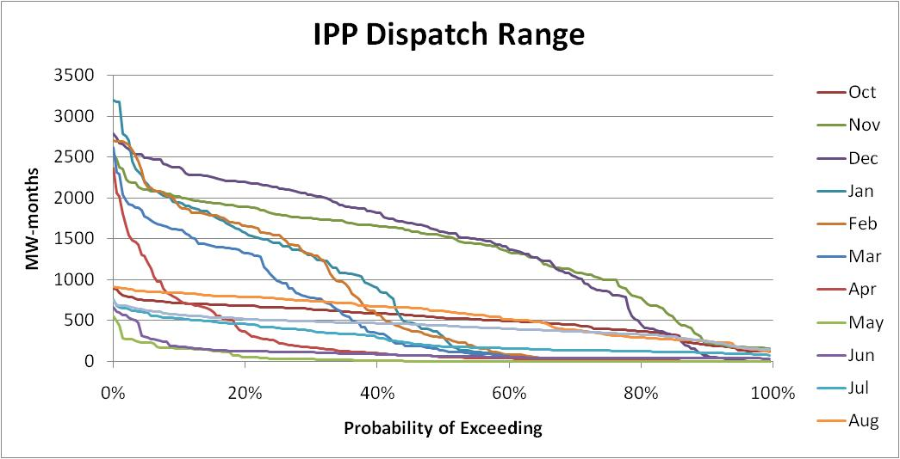
Figure 5
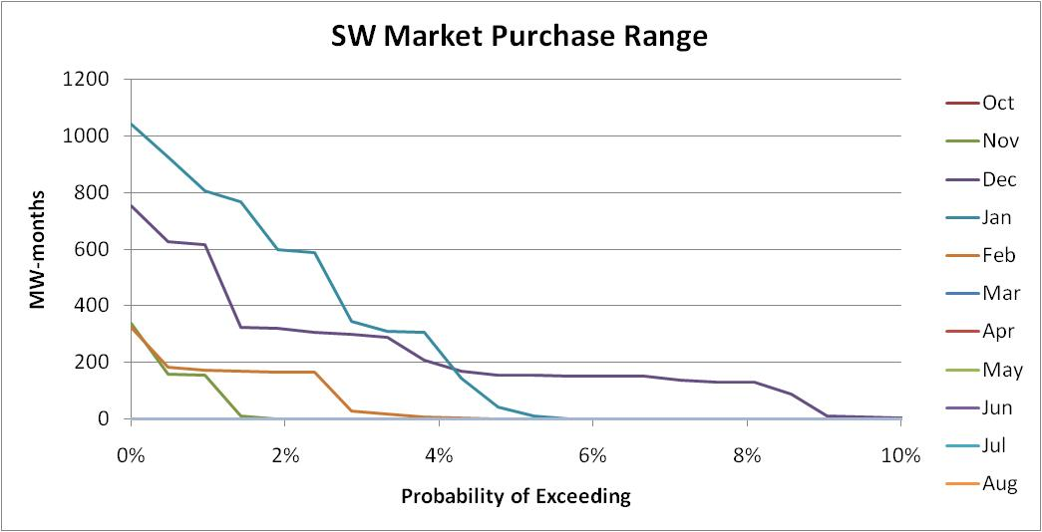
Figure 6
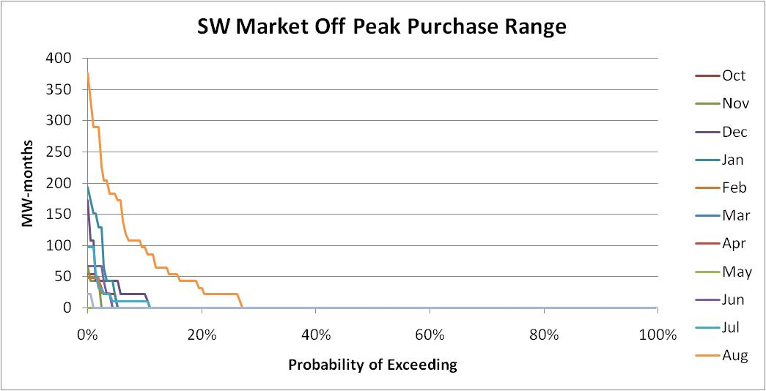
Figure 7
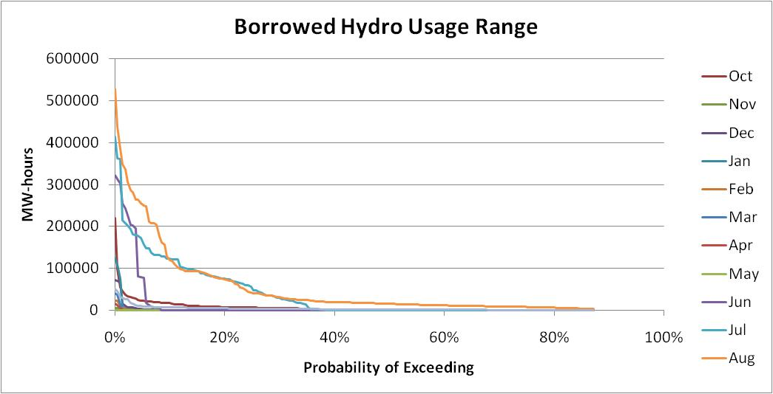
Figure 8

Use of Demand Response and Standby Resources
Some resources in the Northwest are too small to model explicitly, while others may be available but are not intended to be used every year. The first set of such resources, namely demand response operations, are expected to be used every year to help lower demand during peak hours of the day. These resources only have a capacity component and are not intended to provide extended energy relief.
The second set of resources, or standby resources, are composed of load curtailment actions or generating resources that are contractually available to utilities. These resources are available to help reduce peak hour load and may also provide some energy assistance.
Demand response resources are small, only contributing 60 megawatts of peaking reduction during winter and 120 megawatts during summer. Standby resources have larger capabilities, with about a 600 megawatt peaking contribution and an annual energy availability of 83,000 megawatt-hours.
Figures 9 and 10 show how often these two resource types may be used, by month. Also shown in those figures are the associated energy and peak LOLP values. Note that the LOLP value for peak is greater than the energy value, which means that is the dominate component in assessing the overall annual LOLP value.
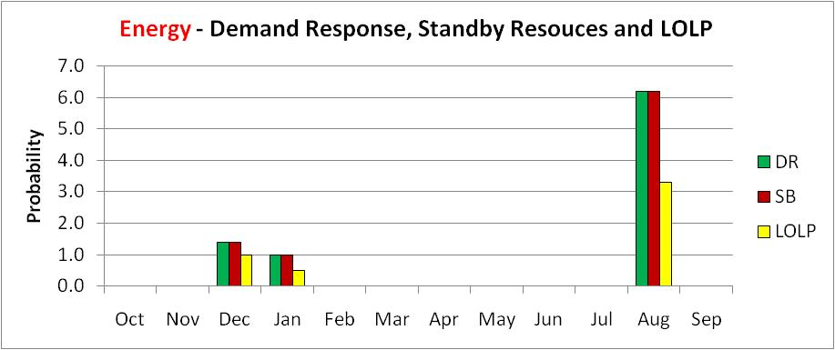
Figure 9
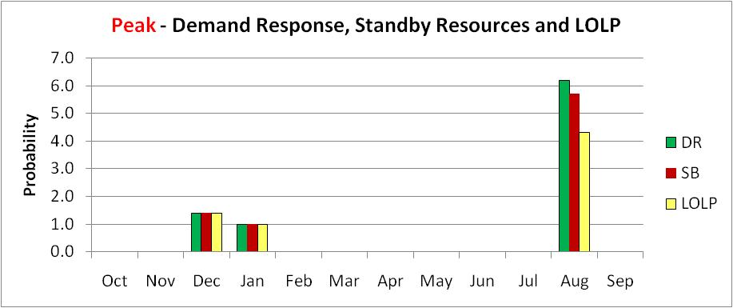
Figure 10

Curtailment Statistics
Sometimes, simply looking at simulation results can provide insight into the behavior of the power system. Table 2 below summarizes a few statistics for the curtailment events reported in our analysis. It should be noted that this particular study was only run with 210 simulations and thus the statistics for curtailment events (as well as the adequacy measures) will have a larger error range.
Besides looking at curtailment statistics, it may also be of great use to examine what conditions existed during the time of each shortfall. Thus, a record of all curtailment events along with the values for the four random variables used in the analysis will be provided in a separate spreadsheet (available on the Forum’s website). The four random variables displayed in the spreadsheet are;
- Water supply, as a percentage of monthly runoff volume
- Temperature, as a percentage of that day’s historical temperature range
- Wind generation, based on historical wind capacity factors from BPA’s wind fleet
- Forced outage conditions
Some attempts have been made to correlate shortfall events with the occurrence of certain temperatures, water conditions, wind generation patterns and forced outages, but unfortunately without much success. This is an area of study that should be explored further.
Exp Events/year | 0.23
Avg Event Duration | 14 | Hours
Avg Event Magnitude | 14569 | MW-hrs
Avg Event Peak | 1098 | MW
Exp Curt Hrs/year | 3.3
% games w/curt | 8.6%
Table 2 – Curtailment Statistics

________________________________________
q:\jf\ra forum\2011\100411 steering draft sos report.docx

