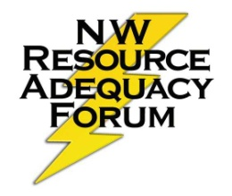
Resource Adequacy Technical Committee Meeting

Large Conference Room, Council Offices
September 28, 2012 – 10am to 3pm

Toll-Free Access Number: 1-800-786-1922
Participant Code: 53922423
GoToMeeting link: https://www1.gotomeeting.com/join/716139929

Agenda

10:00 – 11:00 Briefing on Load Model and Conservation
(Jourabchi PPT)
11:00 – 12:00 Data and Assumptions for Final Assessment
(Fazio PPT)
- Summary of comments received
      - Changes made for the tech-final analysis
(relative to the 8/30/12 draft analysis)
        - Revised code
        - 80-year hydro record
        - Resource data
      - Changes that didn’t get into the tech-final but should be in
the steering-final analysis

12:00 – 1:00 Lunch

1:00 – 2:00 Draft Adequacy Assessment for 2017
(Byrne PPT)

2:00 – 2:30 AVISTA’s Adequacy Work
(Kalich PPT)
2:30 – 3:00 Action Item
Decision whether to approve and forward results to the steering committee

