Resource Adequacy Status Report for July 2013

I. Data Updates

Data | Status | Notes
2019 Loads | Draft done  Final TBA | Preliminary 2019 loads under internal review  Ready for committee review by August  Final loads by early September
Generating resources | In progress | Preliminary by July
SW Market resources | In progress | New CEC data is available  Will also use AURORAxmp runs
Wind | In progress | Asked members to provide non-BPA fleet data
Energy Efficiency | In progress | Council staff, working on hourly shapes  Consider adding EE explicitly (instead of in loads)
Contracts | In progress | Will use BPA White Book data, need to format
New Peak vs. Energy Curves | By August | Update to 80-hydro years (McCoy contract)
Review INC/DEC | By August | BPA will provide any changes
Investigate BC market | TBA | New task needs assignment
Investigate non-NW wind and Entitlement as market supplies | TBA | New task needs assignment
Review transmission nomogram and capacities | TBA | Council staff
Identify policy assumptions for steering committee | TBA | John will send a draft list out to tech members  See Appendix C
Identify key sensitivities for detailed study | TBA | See section IV below
Data for 3rd node | TBA | Has not yet been assigned

II. Model Enhancements

Enhancement | Status | Notes
Canadian operation | Done | Undergoing testing, will allow random hydro
14-Period years | Done | Tested and approved
Weekly hydro | In progress | Will not be used for next assessment
Transmission nodes | In progress | Add Idaho node, needs data, testing
User interface | In progress | ETA late 2013
Hourly hydro review | TBA | Multiple issues, eliminate “false” curtailments
Utility-version of Genesys | TBA | Contractor, BPA, Council staff
Develop means to model distributed generation | TBA | New task needs assignment
Develop means to model DR not already in load record | TBA | New task needs assignment
Develop post-processor DR evaluation model | Done | Needs better curtailment record

III. Proposed Meeting Schedule for 2013-14

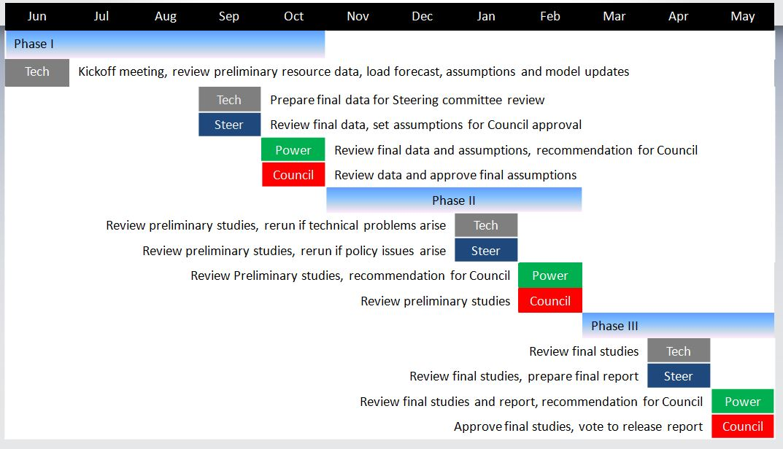

IV. Policy Assumptions for Consideration by the Steering Committee

- Amount of SW market to include in the reference case
- Amount of market provided by non-NW wind
- Amount of market supply provided by BC
- Amount of market supply available from the Entitlement
- Amount of energy efficiency to include in the reference case (Council target or other)
- Amount of new wind to include in the reference case (licensed-and-sited or RPS)
- Shape for energy efficiency in the reference case
- Assumptions relating to DR or distributed generation (more specificity needed)
- Include sited-and-licensed resources in reference case or use different assumption?
- Amount of borrowed hydro to include in reference case
- Definition of standby resources (post processor adjustment of curtailment record to include the effects of standby resources not modeled in Genesys)

________________________________________
q:\jf\ra forum\2013\adequacy status july 2013.docx

