W. Bill Booth  Chair  Idaho | 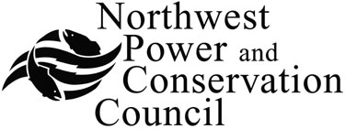 | Bruce A. Measure  Vice-Chair  Montana
James A. Yost  Idaho  Tom Karier  Washington  Dick Wallace  Washington |  | Rhonda Whiting  Montana  Melinda S. Eden  Oregon  Joan M. Dukes  Oregon

Generating Resources Advisory Committee

AGENDA

Thursday August 21, 2008
10:00 AM - 3:00 PM

Northwest Power and Conservation Council Central Offices
851 SW Sixth Avenue
Suite 1100
Portland, Oregon 97204
1-877-848-1997 Guest Code: 319

10:00 Call to order - Jeff King
Introductions
Review of agenda
Approval of minutes of July 17 meeting

10:15 Approach to the wind resource assessment – Jeff King

11:00 Introductory discussion of the demand for and supply of ancillary services - Maury Galbraith

11:50 Break for lunch

1:00 Proposed wind plant capital cost assumptions - Jeff King

1:40 Assessment of thermal resource commitment parameters - Maury Galbraith

2:20 Fossil fuel price forecast - Jeff King
Discuss proposed revisions

2:50 Status of ongoing action items
Operating and maintenance cost assessment
Pumped storage workshop

3:00 Adjourn

