NEET Workgroup #5 Workforce of the Future

May 2009 Update

- Introduction

Work group five was drafted to address the central question, “Facing today’s demographics, how do we create systems that build and sustain energy efficiency talent to meet today’s and the future’s needs?” In the preliminary meetings in mid-August and early September of 2008, the workgroup decided to focus its approach through input from group member expertise and a literature review. Additionally, a decision was made to focus on short-term actionable items. Staff from PSE and PacifiCorp provided support and conducted research.

- Brief Discussion of Background and Literature Review

A convergence of factors presents both opportunity and challenge for increased energy efficiency deployment. Economic and policy actions are driving the expansion of energy efficiency at a rapid rate. Long term projections of energy supply costs are climbing making energy efficiency an alternative resource choice. 26 states have renewable portfolio standards in place and 16 states have energy efficiency requirements in place.

The growth of energy efficiency both regionally and nationally is also documented from a variety of sources. The National Action Plan for Energy Efficiency reports energy efficiency programs will increase 15% in the near term and energy service companies (ESCO) revenues to increase 22%. The American Solar Energy Society counts 8 million jobs created in the U.S. Energy Efficiency industry in 2006 and The Center on Wisconsin Energy estimates 10 jobs are created for every $1 million invested in energy efficiency measures.

While these trends are reason for optimism for the growth of energy efficiency in the Northwest, several other factors present challenges that may impede the projected attainment of energy efficiency. Primary among these is the imminent retirement of 50% of the workforce in the coming five years. Magnifying the importance of this trend is a general decline in the working age cohorts of the population until 2030, and particularly declining numbers of workers in the skilled trades as well as graduates and enrollments in engineering programs. Confounding these broader trends, there is difficulty in identifying true workforce and job data for the energy efficiency industry. Employment in energy efficiency is refracted across utilities, federal and state programs, manufacturing, construction, and other disparate job classifications. This makes it especially challenging to assess the specific numbers of employees needed to attain energy efficiency goals. Additionally, the economic downturn of 2008 may dampen energy efficiency demand for the short term and it is likely that state discretionary funds may not be available for workforce issues until a recovery ensues.

- Findings and Issues

Among the available literature for review, a great deal was written about Green Collar/Green Economy Job development, but little specific mention or analysis of energy efficiency projections or needs. Some efforts that are slated for completion beyond the timeframe of the Northwest Energy Efficiency Task Force offer promise such as the DOE office of Energy Efficiency and Renewable Energy draft report from LBNL on Commercial and Industrial workforce needs, due in February 2009. Also a report is expected in August 2009 from the Oregon Economic and Community Development Department which has a workgroup examining energy efficiency as part of its Clean Tech Action Plan.

A suite of jobs have been suggested as areas of need including mechanical engineering, building commissioning, HVAC specialists, program management and skilled labor positions in construction, metal working, pipe fitting, and others. However, there has not been a specific classification of numbers of positions needed nor prioritization of need.

Research has also indicated that there is a lack of strategic coordination and communication among institutions able to address the impending need. These include: utilities, education, organized labor, state workforce coordinating boards, community based and non-profit organizations, and private training programs. There is a lack of data as to the skills required to complete energy efficiency work, types of positions needed, demand for these positions, and pay rates. Colleges, labor union training programs and other learning institutions need this information in order to expand their offerings and attract students. One may also conclude that given the lack of specific focus on energy efficiency in the reviewed studies, there is likely a lack of public awareness of the career opportunities and contributions of energy efficiency to the green economy. Table 1 summarizes the primary research findings.

Table 1
Key Themes That Emerged From the Literature Review
Lack of data for energy efficiency workforce development | - Skills required  - Positions needed  - Pay rates  - Public Awareness
A lack of strategic coordination among energy efficiency workforce development players | - Community based training programs  - Education  - Organized labor  - Private training programs  - State workforce and training boards  - Utilities and Industry
Lack of funding for workforce development training | - Present economic downturn  - State budget deficit (WA)
- Recommendations

Given the research findings and regional resources, three recommendations summarized in Table 2 on page 4 are put forward to advance the development of a regional energy efficiency workforce. A brief explanation of each recommendation follows with a rationale for the best organization to carry them forward. Figure 1 on page 5 presents a high-level organizational scheme illustrating a regional model for energy efficiency workforce development.

Recommendation 1

The findings from the literature review make clear that a primary step is to conduct an assessment for the region that will define and segment energy efficiency from other green economy jobs, establish skill standards, and identify job classifications that will be referenced across the region. Several studies may have high value informing the regional study and need to be tracked closely as a part of this effort. These studies are listed as a part of this action item in Table 1. Ken Canon will manage the implementation of the research study. Ken is well known among key players in the region and is well positioned to coordinate the project. He will select and manage a third-party professional assessment with a scope that is inclusive of the many dimensions of energy efficiency employment as outlined above.

Recommendation 2

The second recommendation advises that a clearinghouse of the results and findings from the regional energy efficiency study to be made accessible to the regional organizations. The clearinghouse should include relevant study data such as skill standards and defined energy efficiency job classifications, best practices in recruitment and retention, and a place for organizations to post openings. Additionally, an index of regional education and training program needs, offerings, and providers should be included. This will help both employers and education and training organizations speak a common language regarding their employment needs and program focus. The Center for Energy Workforce Development (CEWD) is a national organization presently accomplishing this mission with regards to careers in energy production and infrastructure. As the Northwest has considerable experience with energy efficiency, the region and CEWD are well suited to begin a partnership integrating energy efficiency and workforce development.

Recommendation 3

The research findings also support the establishment of a strategic coordinating body for the region. As articulated earlier, energy efficiency is a diffuse industry with employment and training across a broad range of occupations. A central coordinating body will partner with other entities in the region to advise training institutions on energy efficiency skills standards and aid them in the development of their curriculum. The coordinating body will establish and maintain communication between industry, labor and training institutions to: assure that quality programs are developed, industry’s needs

Table 2 NEET Workgroup Five Summary of Recommendations
Area of Focus | Recommendation | Responsible party | Timeframe of Accomplishment
Define need for and job classifications of energy efficiency workforce | Conduct a regional workforce assessment for Energy Efficiency detailing:  - Skill standards  - Job classifications  - Employment levels  - Employment demands  - Pay scales  Track and integrate results of:  - Sustainable Oregon Workforce initiative (3E Strategies)  - Washington State Green Workforce Labor Market Survey  - LBNL Study of C/I workforce needs | Ken Canon | 2009
Build and maintain a regional jobs and skills clearinghouse | Establish a clearinghouse for:  - Skill standard assessment data  - Best practices in recruitment and retention  - Place to post job openings  - An index of training programs and providers | CEWD | 2009-2010
Facilitate strategic Coordination of the workforce pipeline. | Create/leverage an education and training model for the region | Center of Excellence for Energy Technology at Centralia College | 2009-2010

are met by graduates, and students are being placed in appropriate positions. It will also help avoid unnecessary duplication of effort and therefore more efficient use of available funding in the region. Training programs will continue to be developed, conducted, and controlled by individual schools, labor organizations, and local economic development agencies.

The Center of Excellence for Energy Technology at Centralia College (COE) has built up substantial expertise in workforce development for the electrical energy sector, and has worked beyond its state borders to consult with sister institutions in Oregon and Idaho about developing similar workforce programs. It has also demonstrated the ability to work with a diverse set of education and training institutions, each operating in a unique set of mission goals, funding systems, and accountability requirements. Given its proven track record, it makes sense that the COE takes this role of acting as a facilitator in the region complementing the roles recommended for CEWD.

Figure 1 Regional Energy Efficiency Workforce Development Model
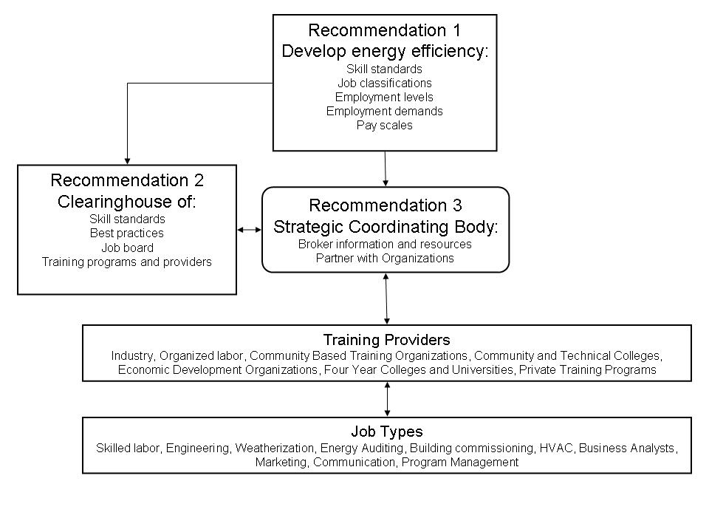

Note the examples listed in the above diagram are intended to be a representational though not exhaustive list of involved organizations and job type.

- Transition and Next Steps

Ken Canon will manage the transition from NEET Workgroup #5’s research and recommendations regarding energy efficiency workforce development through the implementation phase culminating in the establishment of an Energy Efficiency Workforce Pipeline for the Northwest Region. The NEET Workgroup #5 Executive Chairs will serve as an interim oversight board during the transition period until a handoff to a newly formed and longer term oversight body is complete. Mr. Canon and the interim board will confer at regular intervals over the course of the project as milestones are achieved or as alternative strategies are required. NEEA will serve as a fiscal agent for regional funding to complete the project.

Regional fundraising among key players will provide for preliminary startup costs for implementing the recommendations. Given the present economic conditions and state budget constraints, it is assumed that additional grant based funding and contributions from the energy industry will need to be acquired to implement the recommendations in this report. Given the regional scale of the project, public/private collaboration, diversity of the parties involved, and political will to stimulate green economic development, the energy efficiency workforce development project appears apropos to attract funding. States and Workforce Development Councils in the region will have received dispersements from the Department of Labor and the 2009 American Recovery and Reinvestment Act that are aligned with the outcomes of the recommendations and liaisons with those entities should be approached for funding requests.

The COE will need $50,000 for startup costs. This money will be used to secure a professional grant writer, part-time administrative support, and travel within the region. Work will begin immediately to secure partnerships among the utility industry, organized labor, community and technical colleges, workforce development boards, and economic development councils. The initial approach will identify educational leaders in each state for example: Idaho States Energy Systems Technology Education Center Program, Montana State University, Lane Community College, Portland State University, and the existing relationships between Washington Community and Technical colleges and the COE. Simultaneously the hired grant writer will research and secure funding for the regional effort to complement funds supplied by industry. These preliminary steps will enable the COE as the strategic coordinating body to:

- Develop strategic partnerships.
- Ensure quality of existing training programs and coordinate the development of new programs.
- Maintain the training inventory portion of the regional clearinghouse.
- Facilitate the growth and maintenance of the workforce development pipeline.

Energy Efficiency Services Workforce Assessment. January 2008. Chuck Goldman LBNL, Report to National Action Plan for Energy Efficiency Leadership Group.
Renewable Energy and Energy Efficiency: Economic Drivers for the 21st Century. 2007 Roger Bezdek, Management Information Services, The American Solar Energy Society
Greener Pathways: Jobs and Workforce Development in the Clean Energy Economy. 2008 Sarah White and Jason Walsh, Center on Wisconsin Energy, The Workforce Alliance, The Apollo Alliance.
Workforce Survey of Electric Sector Employers in Washington and Oregon. January 2008. Alan Hardcastle, Washington State University Energy Extension Program.
Analysis of Clean Energy Workforce Needs and Programs in Oregon. May 2008 3E Strategies, Sustainable Oregon Workforce Initiative.

